**Terraform azure install NodeJS on ubuntu virtual machine**

Git repo link: <https://github.com/pritamworld/Terraform-Azure-VM>

1. Install Terraform.

On Mac:

**$ brew install terraform**

On linux / WSL

**$ apt install terraform**

On windows

<https://developer.hashicorp.com/terraform/downloads>

choose platform windows and download binary

After downloading on Your machine open terminal and run

**$ terraform -help**

(For windows open the terminal in same directory as you downloaded the binary).

1. Create a new directory where we’ll store the terraform code.

**$ mkdir terraform_class_activity**

Then cd Into the directory

**$ cd terraform_class_activity**

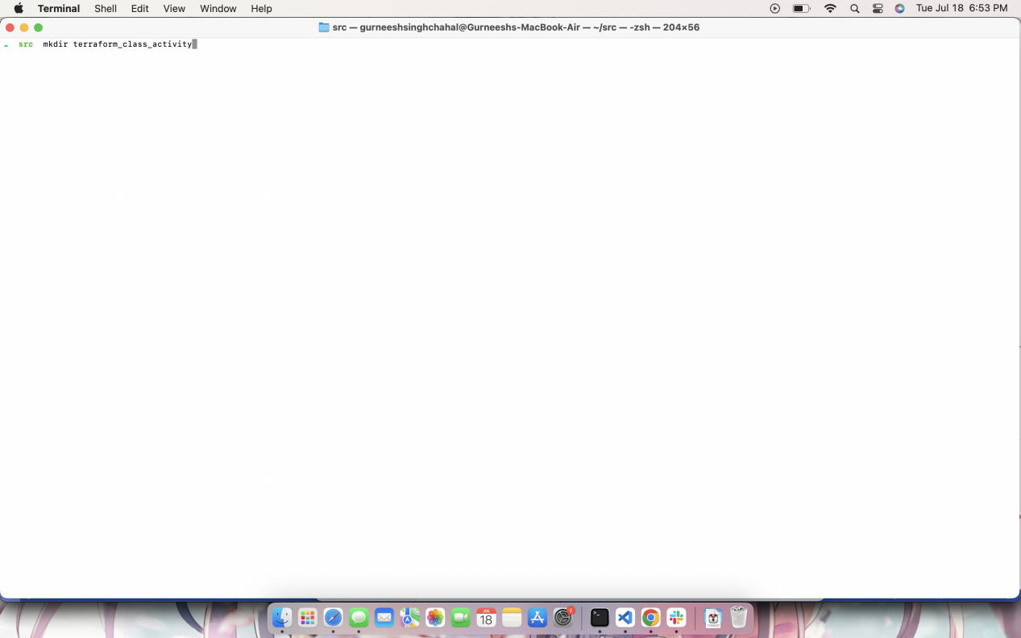

1. Initialize terraform directory

**$ terraform init**

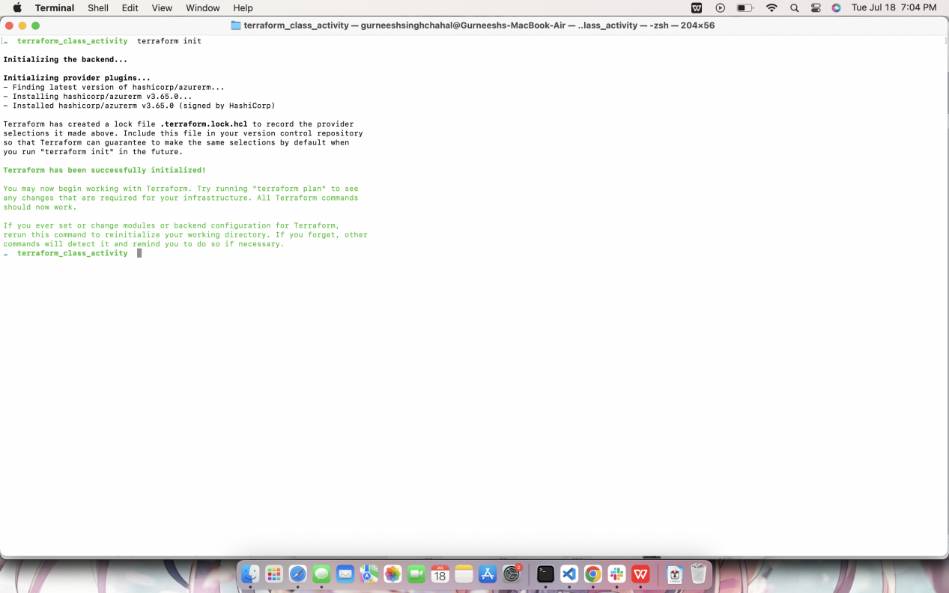

1. Create a main.tf file save it in the directory you created, where we configure
   1. Resource group
   2. Network Interface
   3. Security group
   4. Ubuntu Virtual Machine
2. Scripted in main.tf file.
3. Install azure cli (<https://learn.microsoft.com/en-us/cli/azure/install-azure-cli> )

On mac:

**$ brew install azure-cli**

On Linux/WSL:

**$ apt install azure-cli**

On windows:

<https://learn.microsoft.com/en-us/cli/azure/install-azure-cli-windows?tabs=azure-cli>

1. Login on Azure CLI

**$ az login**

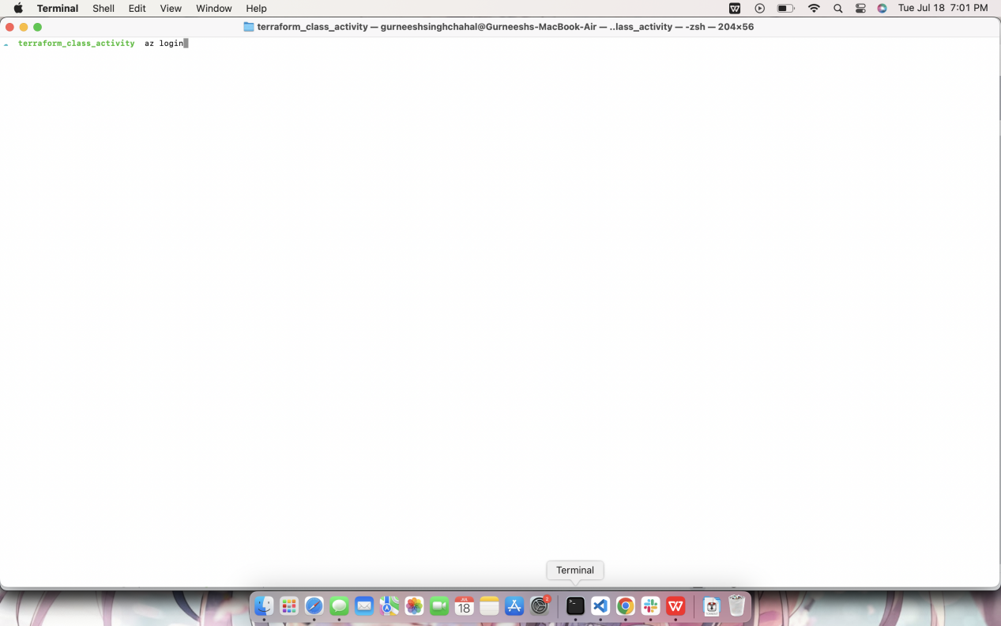

After running this command, a new window will open on your browser asking you to login.

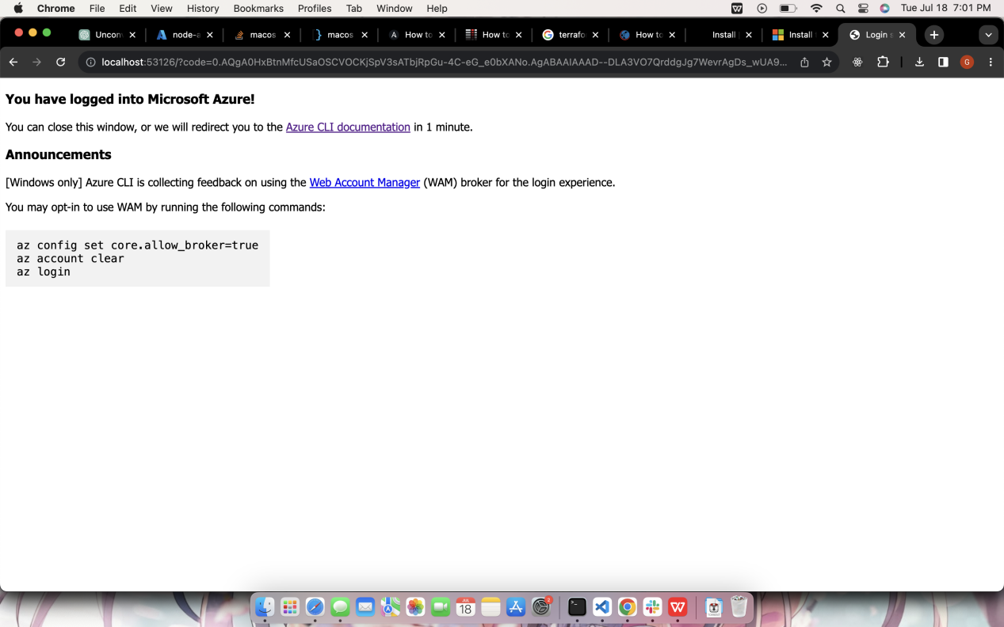

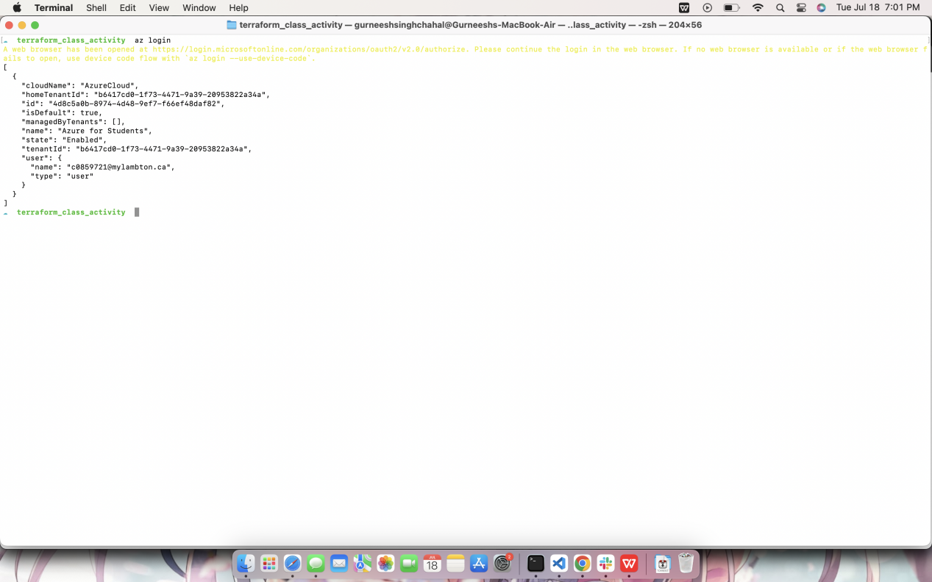

1. After redirect
2. Get to terminal which is opened in your directory and validate your terraform script

**$ terraform validate**

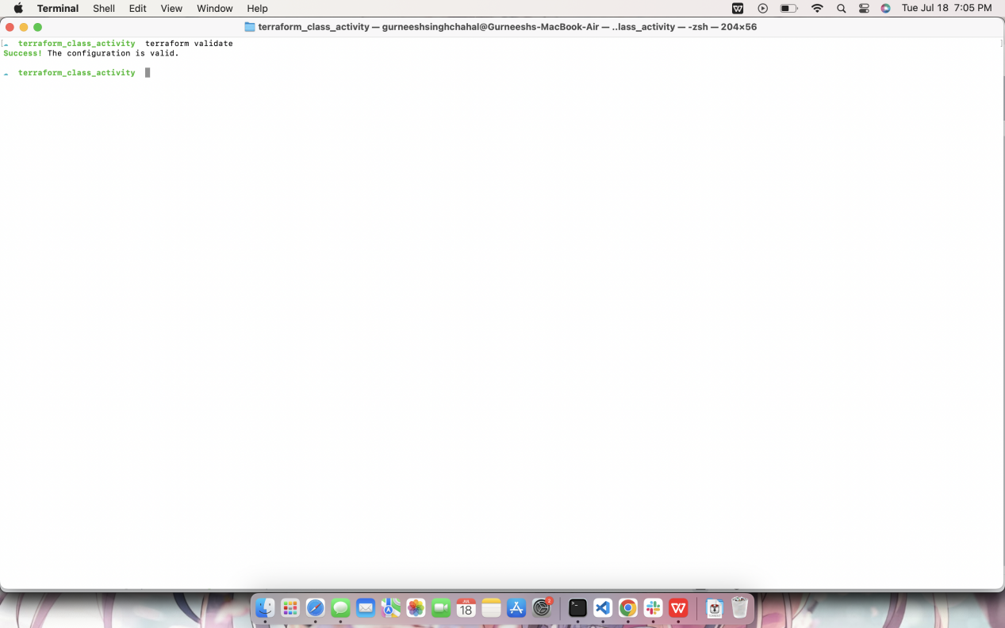

1. Plan the terraform script and monitor what resources are getting created

**$ terraform plan**

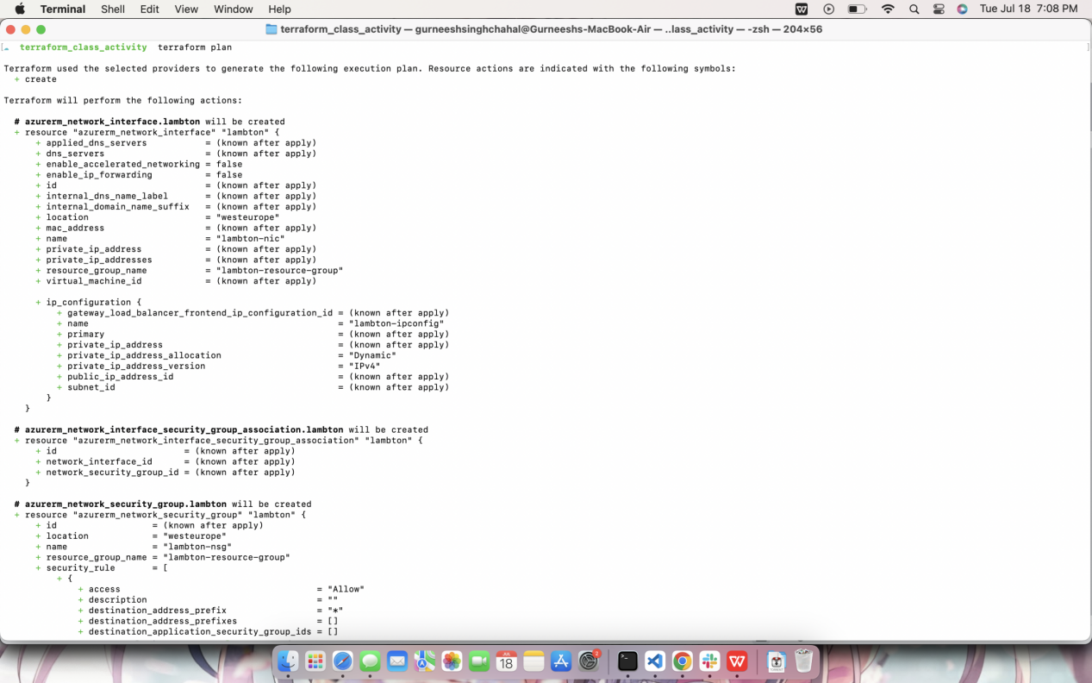

1. If everything seems fine apply the terraform script to create all these resources.

**$ terraform apply**

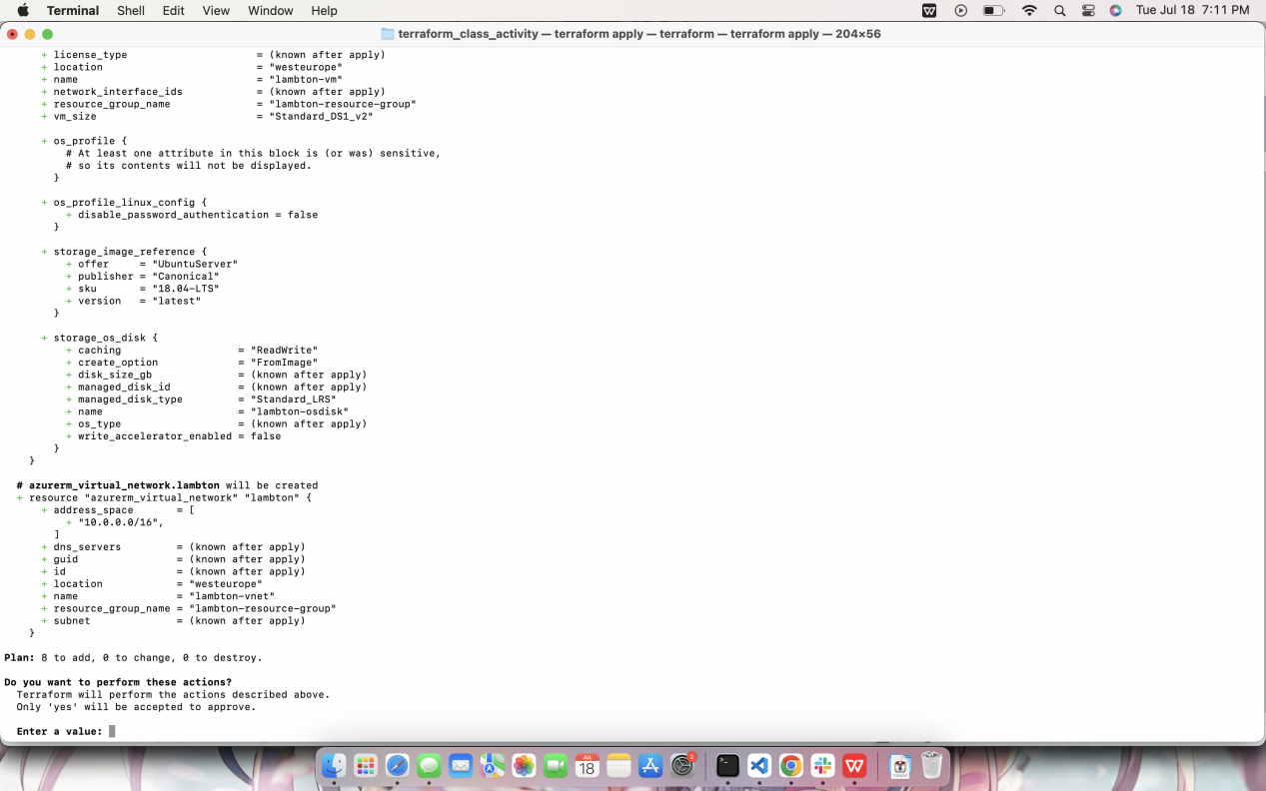

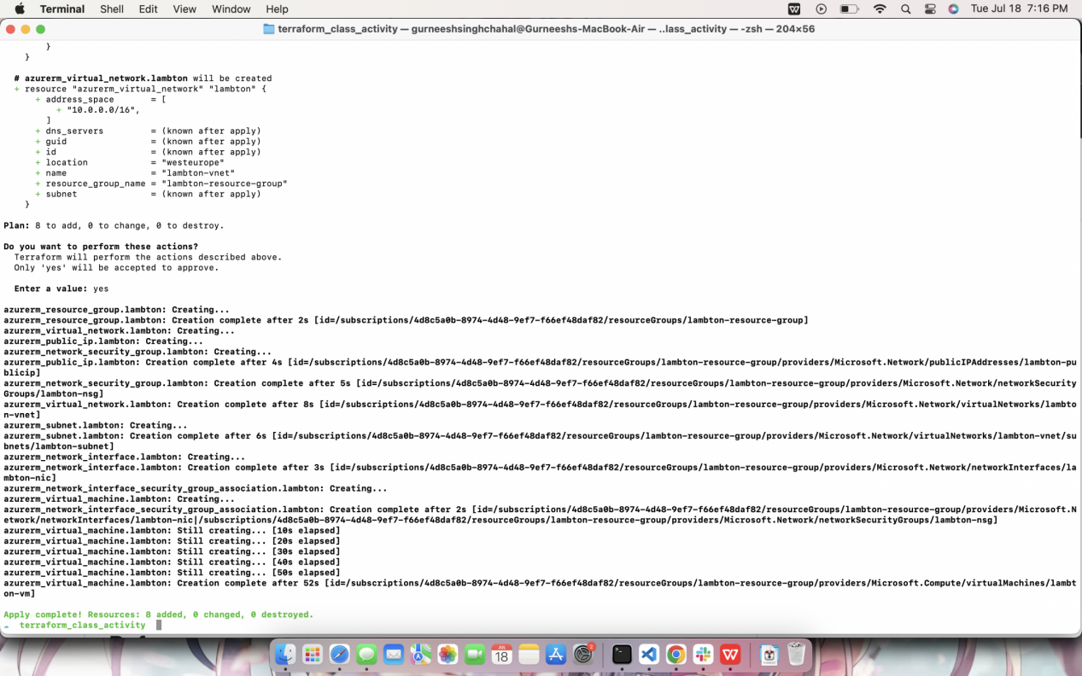

1. After the resources are created, run the ansible script to install nodejs app on ubuntu server that we created.
2. SSH on the server.